**If you build it, they will come: coastal amenities facilitate human engagement in marine protected areas**

Marine protected areas (MPAs), areas in the ocean where fishing is prohibited or restricted, are commonly used as tools to protect biodiversity, recover fisheries, and promote other beneficial human experiences. While the conservation and fisheries impacts of MPAs have been well studied, the impacts of MPAs on other dimensions of human use -- such as recreation, education, and scientific research -- have received less attention. Identifying traits of MPAs that promote or limit human engagement is critical to designing MPA networks that achieve multiple goals effectively, equitably, and with minimal environmental impact.

In our recent paper, we develop a novel and transferable framework for quantifying human engagement in California’s MPA network, one of the largest MPA networks in the world. We assemble and compare diverse indicators of human engagement -- leveraging information from citizen science programs, social media platforms, and government datasets -- that capture recreational, educational, and scientific activities across California’s MPAs.

We find that human engagement is correlated with local population density: unsurprisingly, the more people that live close by, the more people that engage in an MPA. However, we also find that MPAs near tourist destinations, adjacent to state parks and their amenities, and with long sandy beaches generate more engagement than would be expected based on population density alone. Conversely, remote MPAs without sandy beaches or parking lot access had lower than expected human engagement.

What does this mean as the world aims to expand MPA coverage to protect 30% of the ocean by 2030? On one hand, human engagement can be promoted by developing land-based amenities that increase access to coastal MPAs or by locating new MPAs near existing amenities during the design phase. On the other hand, human engagement can be limited by locating MPAs in areas far from population centers, coastal amenities, or sandy beaches. This choice depends on management goals. Our paper provides a transferable framework for current and future MPA networks to track progress towards meeting their own human use objectives.

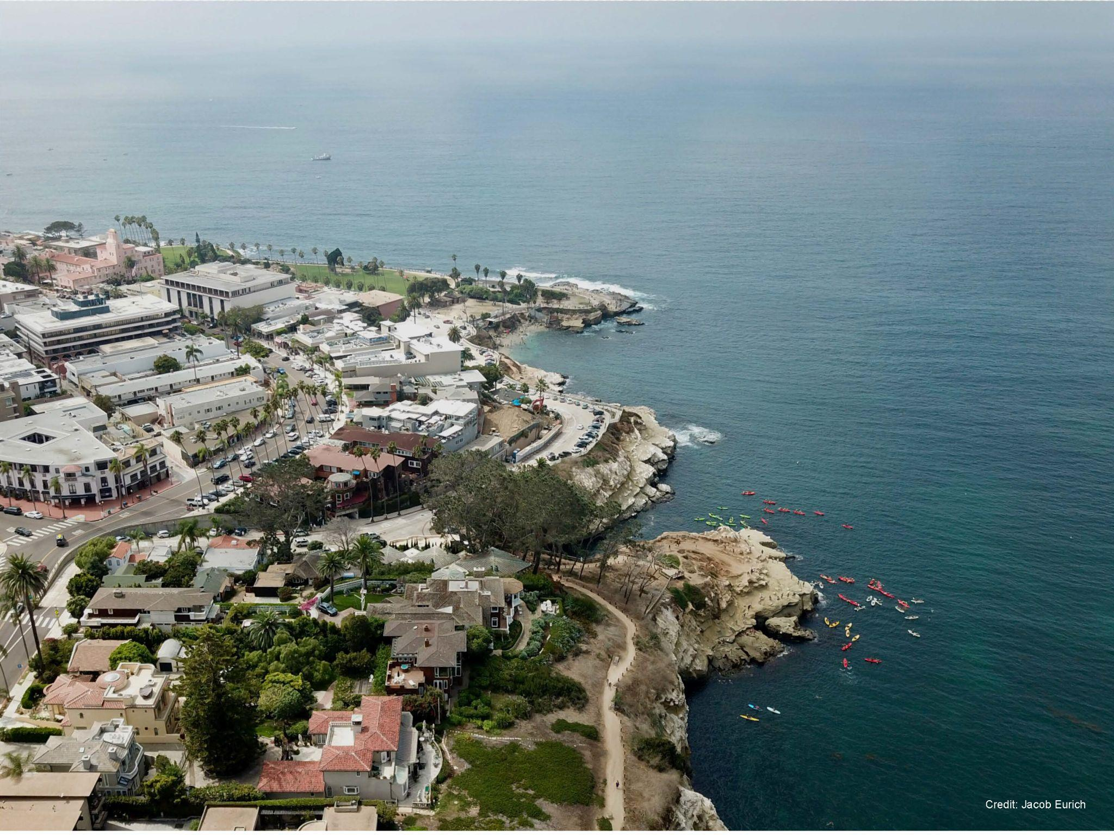

Kayakers exploring the Matlahuayl State Marine Reserve off of La Jolla Cove in San Diego, California, USA. Photo by Jacob Eurich.

## Guidelines

**Why write a plain language summary?**

To raise the profile of your work and make it accessible to the widest possible audience, we strongly encourage you to write a plain language summary, explaining the importance of your work in a way any interested non-specialist could understand.

As well as making your work more accessible to non-scientists, policy-makers and practitioners, plain language summaries can also promote your work to other researchers, from your own discipline and beyond. A good plain language summary will get more people reading your work.

Your plain language summary will be added to our journal blog, linked to your paper and will be freely available to read. We also encourage you to use the plain language summary directly to communicate your work to a wider audience—post it on your blog, share it on social media, use it to explain your research.

**How to write a plain language summary?**

**Title –** Start with a shortened title (less than 120 characters) that will attract the reader and summarise the key message of your paper (like a newspaper headline) in clear terms. Unless you're very lucky, this will be different to the paper title.

**The main text should be:**

* 250–350 words
* Written in clear and simple language (and contain NO jargon)
* Written in the first person
* Compelling and provide a clear explanation of your work
* Written to allow the reader to get a basic understanding of what the research is about, how it was done, what was concluded and what are the implications without needing to refer to the paper.

**Illustrations –** Include a high-resolution image (along with a short caption and photo credit). We use summary images on social media and for cover photos. Examples of images could be your field sites, scientists at work, or perhaps something more lateral – anything, in fact, to make your work more accessible and interesting. Photos of people who can be identified should include a statement to say that they have given consent for the photo to be used. If you are struggling to find an appropriate image check Creative Commons, Pixabay or Pxhere for copyright-free images.  
   
**Useful tips**

* Start with a sentence or two with the take home message, then think about the background of the work, an overview of it and finish with the big picture, policy, or “broader impacts” of the study.
* Try not to think of it as a modified version of the abstract. Unless your paper is written in an unusually simple and straightforward style, it’s unlikely that you can use text directly from the paper in the summary
* What may be a common term for you may be unknown and seem like jargon to a non-scientist, or those working in different fields. If you must talk about, for example ‘cross-reactivity’, then explain in clear and simple terms what that is. Better still, avoid the scientific term altogether and find a simpler way to say it.
* Think about including any important contextual background or findings that might make your work more relevant, interesting and memorable for the reader.
* Ask someone who doesn’t have any specialist knowledge of your specific area to read it.

**We’re here to help**  
We encourage you to write a plain language summary when you are preparing a Revision. One of our specialist plain language summary editors will check and edit your text, although if it contains too much jargon and academic-speak, we will return it to you and ask you to try again.

For more inspiration, all plain language summaries can be found on the journal blog. If you have any questions about writing a plain language summary, please contact the editorial office.